Power Shell 101
Module 1B – PowerShell in VSCode
3/2/2019 Developed by Sam Chung
10/03/2020 Revised by Kim Nguyen
Center for Information Assurance (CIAE) @City University of Seattle (CityU)

Learning Outcomes
- Learn how to install the PowerShell extension in VSCode

Resources
- PowerShell in Visual Studio Code, https://code.visualstudio.com/docs/languages/powershell

Activities
- Installing
- Testing
- Q&A

Installing
- Open your VSCode.
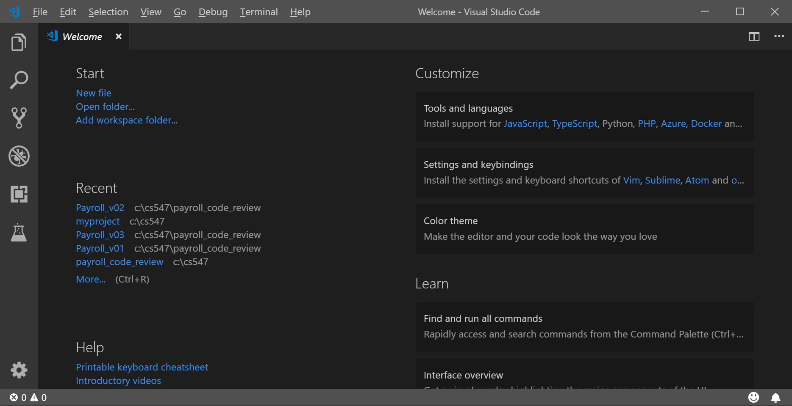
- Open the Extensions view with keyboard shortcut “Ctrl+Shift+X” and typing “PowerShell” and select the PowerShell extension.
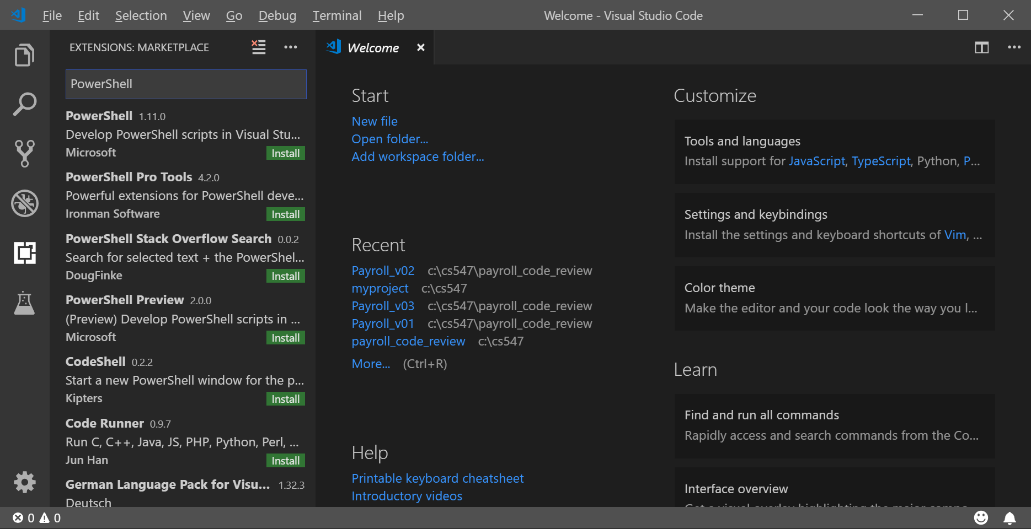

- Install “PowerShell”
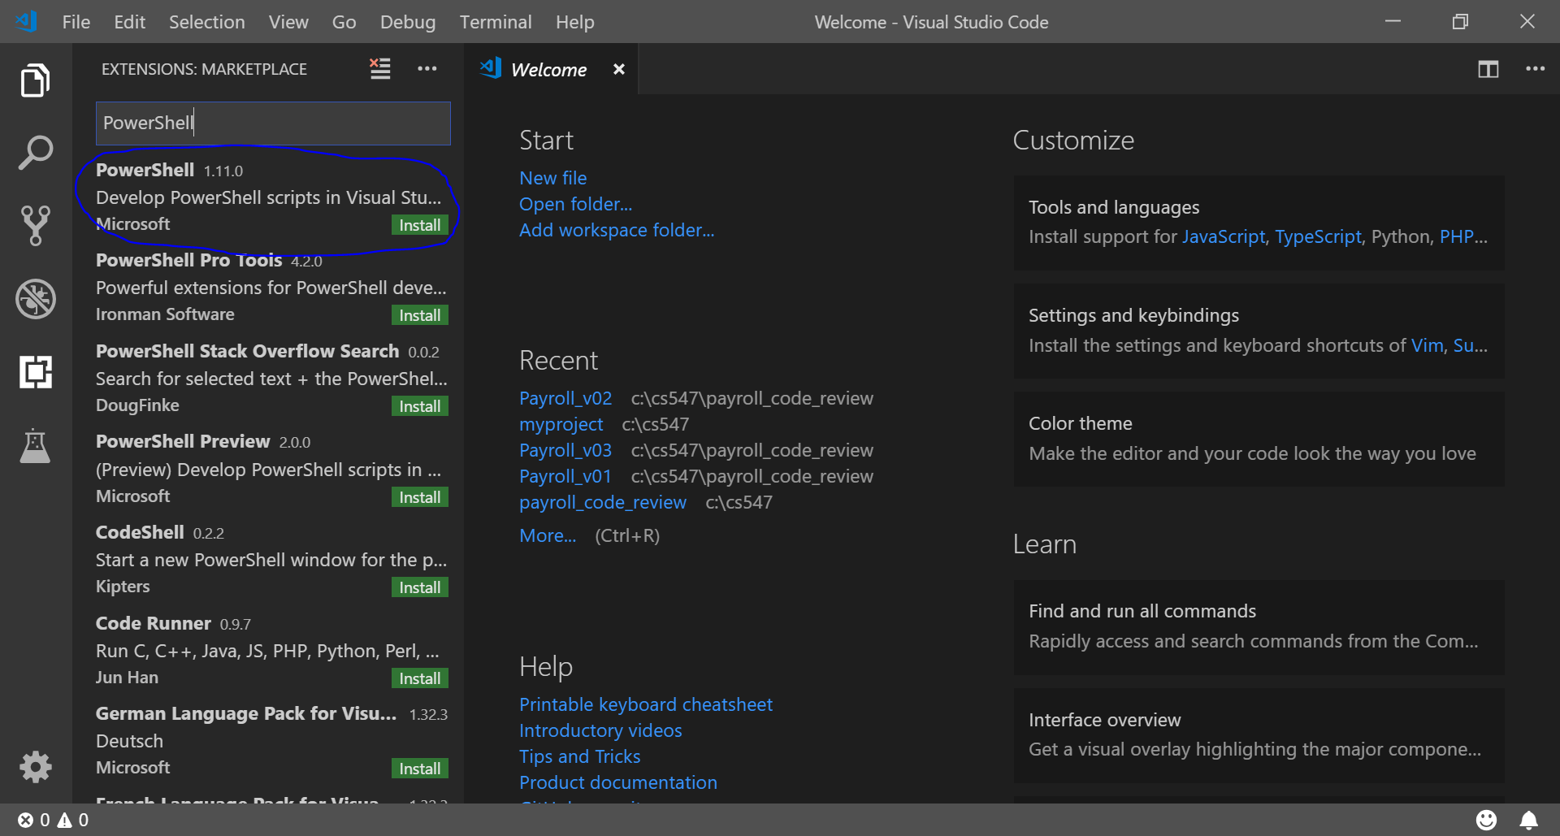
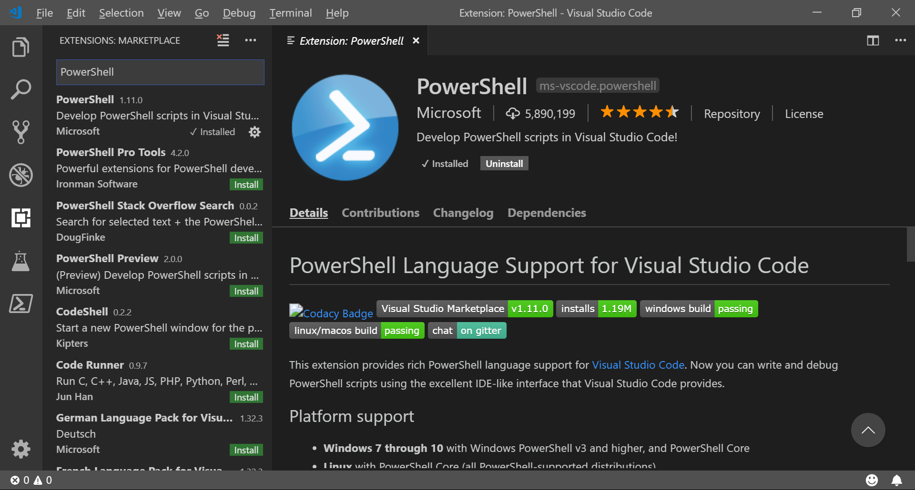
Testing
- To determine what version of PowerShell you have, type “$PSVersionTable.PSVersion”
You can see a little table with four columns: Major, Minor, Build, and Revision.
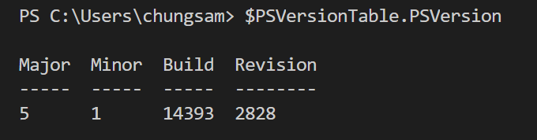

- When you forget PowerShell syntax or want to learn how a command work, if you type “Show-Command command” you can see that a GUI dialog box will be opened to help you complete a command. For example, type “Show-Command Get-EventLog”
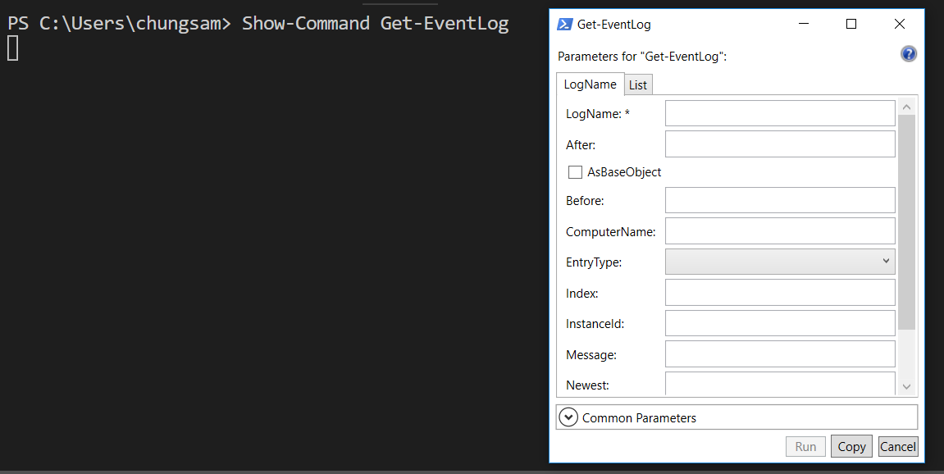

- To know your current directory, type “Get-Location”
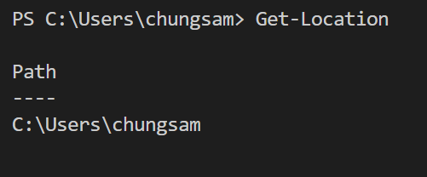

- To know your current directory, type “get-location” and “gl”
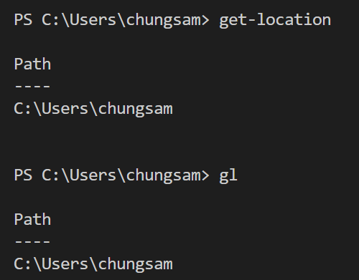

Q&A
Justify your answers with at least one reference.
- What is PowerShell?
PowerShell is a an object based, command-line shell that allows for the automation of tasks. PowerShell is built on .NET Common Language Runtime, which allows it to utilize .NET objects. One of the biggest benefits of PowerShell is that commands can be created and the shell has access to the entire computer file system.

- Why do you need to learn PowerShell

Learning PowerShell allows us the ability to automate tasks that can then be used on an entire network. One example of a task that can be automated through PowerShell is the installation of system updates. Also with PowerShell’s ability to access all files, PowerShell can be used to customize password options for individual accounts within a corporate environment. For example, users can be required to change passwords frequently but users that use two-factor authentication aren’t required to change passwords frequently.

References:
Microsoft. (2020, May 22). What is PowerShell? - PowerShell. Retrieved October 10, 2020, from https://docs.microsoft.com/en-us/powershell/scripting/overview?view=powershell-7

